Pronk, Grant M
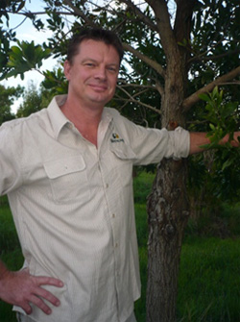
Manager Agarwood. Grant has been a forester for over 23 years and has broad experience in most areas of Western Australian forestry.

GP Forestry's principal consultant is Grant Pronk. Grant commenced his forestry career with the Department of CALM in 1988 and was appointed as a graduate forest officer in 1990. Promoted to Forester Goldfields Region in 1996. He remained working in the government forestry system for 23 years, leaving the Forest Products Commission (FPC) in 2011 as the Arid Forests Manager to establish his own private business, GP Forestry. Over this time Grant developed an extensive set of forestry skills across a broad range of areas including field and plantation inventory, planning, harvesting, revegetation, management plans development, contractor and contract management, product evaluation and environmental management.

Grant has attained a number of tertiary qualifications including an Advanced Diploma in Land Management through the University of Sydney.
Grant is a member of the Institute of Foresters Australia (IFA) and has held the following committee positions:
Chair - Leschenault Community Nursery
Executive Committee Member - Australian Sandalwood Network (ASN)
Board Director - International Sandalwood Foundation (ISF)

